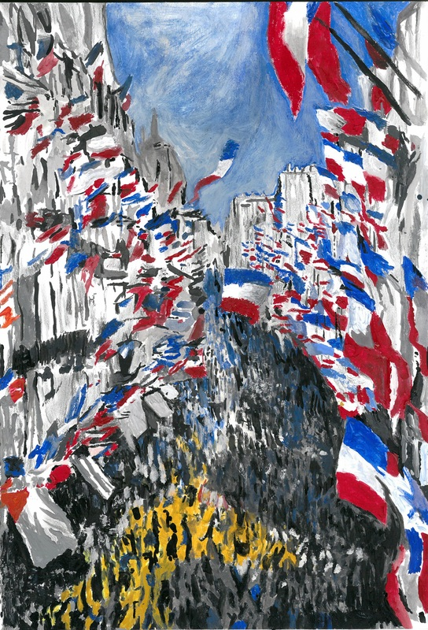
La Rue Montorgueil, Flint Morton Potts, d’après Claude Monet

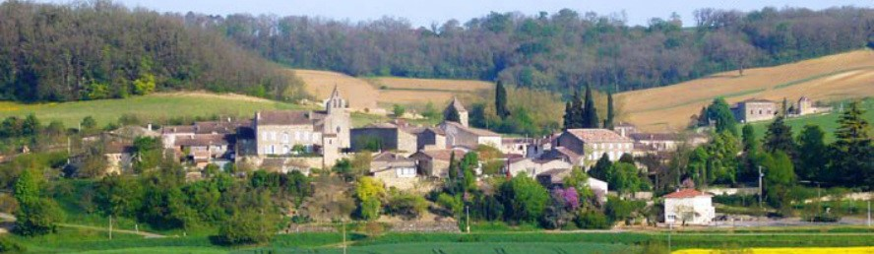

WELCOME to ‘1786’
We hope you have a wonderful stay.
Our manager is Marie-Francoise, tel 00 33 6 03 42 30 23 and I am on 00 44 7894 106563.
You may have already noticed the little shop by the St Saturnin restaurant (great ‘Menu du Jour’), so fresh morning baguettes are now within your grasp...
You will find web links in this info pack. If you want to download the pack to a clickable device, here’s the spot: www.house-in-gascony.com/property-and-local-info.html
And to answer your first, burning question, this is the WiFi code: 1786homemansonville!
Bon séjour
L’Equipe ‘1786’ : Marie, Anne-Laure, Stéphanie, Phi, Jenny, Flint et Fernando

TV

On the mezzanine, we have a Sky digibox for terrestrial and freeview channels. To watch, press the power switch on the LG remote and then on the Sky remote, press the ‘Sky’ button on the top left, then press ‘TV Guide’ to select channels. To switch off, press button top right on remote.

When selecting viewing either on TV channels, dvds, videos or personal devices, choose which ‘input’ you need on the LG remote from button on top right.
AV1 is dvd (connected via scart)
AV2 is video (connected via scart)
HDMI1 is Sky digibox tv channels
HDMI2 is Chromecast, should you want to cast from another device
HDMI3 is 5m cable on left of tv should you want to connect personal devices for large screen viewing

Downstairs we have an Apple box for tv. You can sign in to your own iTunes here and play. The Apple tv is registered for Netflix and other streaming platforms. You can sign in to your Netflix account to access.

CENTRAL HEATING
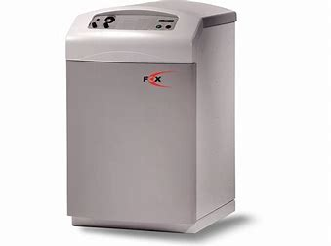

The boiler is in the séjour, behind the wooden door beneath the stairs. It has set programmes which work well but for further adjustment, there is a thermostat at the stop of the kitchen stairs. The key is to allow the boiler time, as some of the volumes of space are rather large!

WATER HEATER
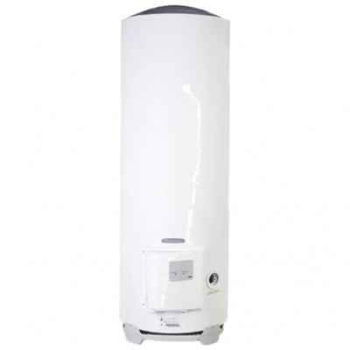
This is found in the cupboard on the top floor bathroom, pre-programmed for good hot water supply.

ELECTRICITY FUSE PANEL
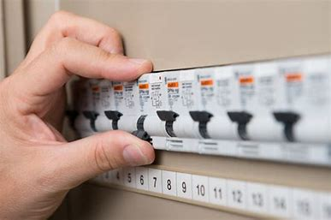
On the kitchen wall (near the microwave) with pull out access.

Our plumber is Nicholas Pinede: tel 06 06 91 33 41

Our electrician is Fluidelec: tel 07 87 17 79 17

DOCTOR

Nearest is 6.7km at 14 route Valence, Miradoux 32340, tel 05 62 28 60 99

VET

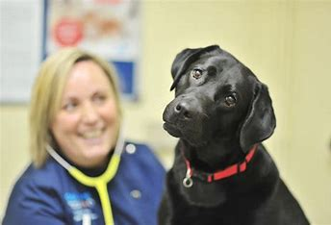

Clinique Vétérinaire des Docteurs Burguière et Rolland, 55 BD Victor Guilhem, 82400 Valence d'Agen
tel 05 63 39 52 10

TOURISM
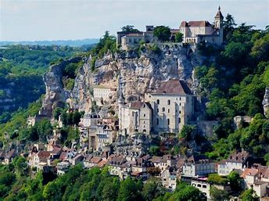
Rocamadour pictured

‘1786’ borders three départements:

https://www.tourisme-tarnetgaronne.fr
https://www.tourisme-lotetgaronne.com
https://www.tourisme-gers.com

SUPERMARKETS

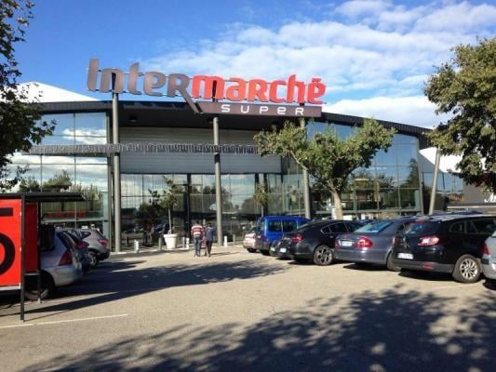

Excellent Intermarché at Valence d’Agen. It has a pick up option and is open on a Sunday morning. https://www.intermarche.com/magasins/11181/valence-d-agen-82400/infos-pratiques
Casino supermarket is in town also.
Hypermarkets, such as E Leclerc, can be found in Montauban and Toulouse. You could spend the day at the delicatessens alone…

RESTAURANTS

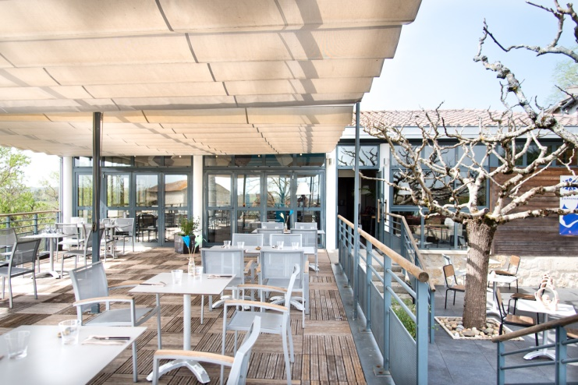

We have a local Michelin starred restaurant, Café Iris, which is an experience. If you ask Cyril, the maitre d’ for the cheeseboard, settle back for a ten minute talk on the cheeses various. www.iriscafe.fr
Jocelyne at St Saturnin does a great job with her local produce and menu range. You can get takeaway pizzas here too. https://le-saint-saturnin.edan.i/

VINEYARDS

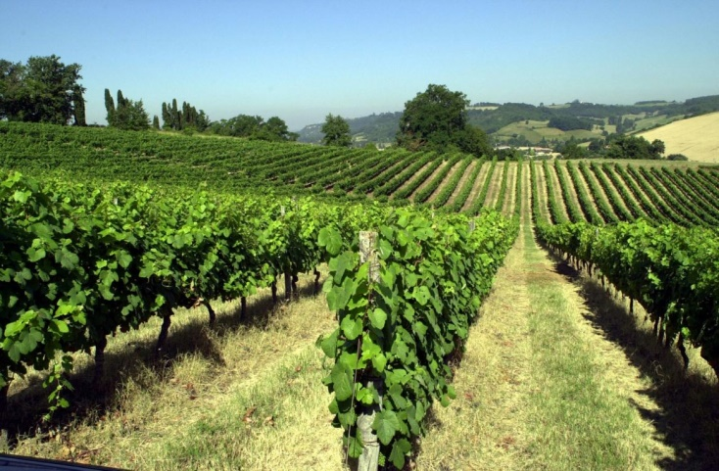

For visiting/tasting/buying

Locally:
https://www.domainedethermes.fr
https://vigneronsdubrulhois.com/en/homepage/

And the supreme estate near Montauban:
https://vignoblesromain.com/domaine-de-montels-albias-82/

WASHING

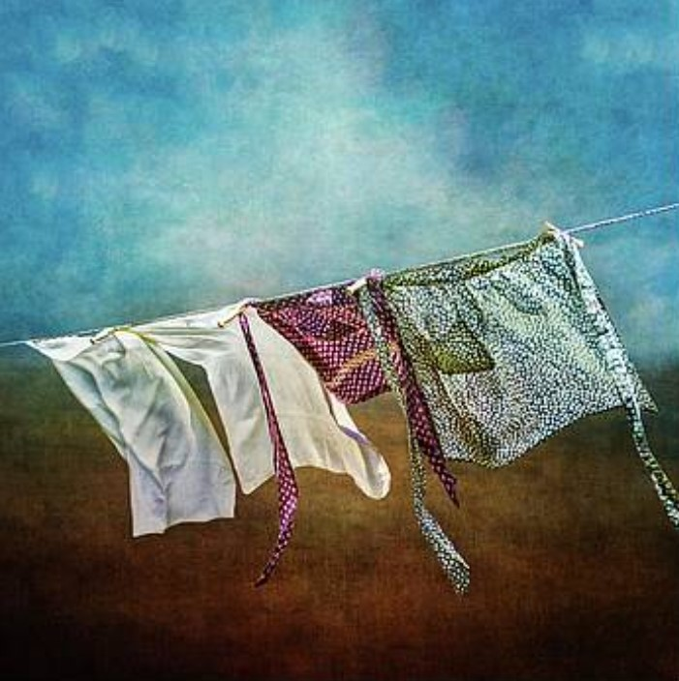

There is a washing line in the courtyard in the corner behind the olive tree. Just pull in a diagonal and secure around the stone at the far end. There’s a pole too. A clothes horse is folded under kitchen stairs. And the ironing board is to the right of the fridge, with iron on top.

OVEN AND HOB

The oven is electric and the hob is connected to a gas bottle. There is a spare under the kitchen stairs. If you need to use the spare, please mention this to a team member.

WASTE

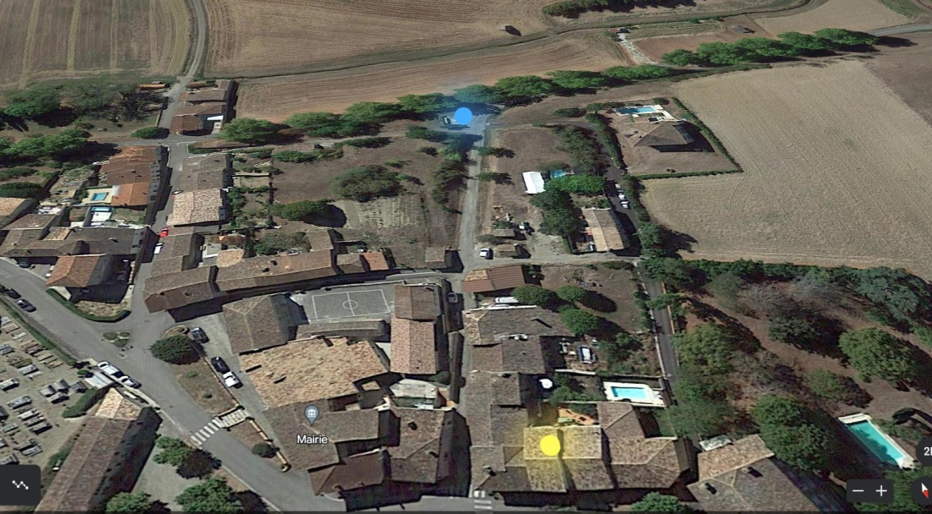

The blue spot in the above picture shows the village refuse and recycling point. ‘1786’ is the yellow spot. There is no collection in French villages.

WATERING
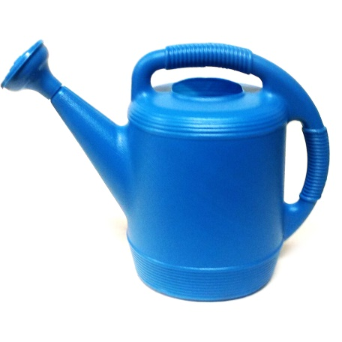
Please water the plants if there is no rain. There is a watering can in the courtyard corner, beyond the ‘cloakroom’.

Market Days Tarn et Garonne
Monday
Caussade
St-Nicolas-de-la-Grave
Tuesday
Caylus
Montech
Nègrepelisse
Valence-d’Agen
Wednesday
Finhan
Grisolles
Labastide-St-Pierre
Lafrançaise
Laguépie
Lauzerte
Montauban
Septfonds
Thursday
Castelsarrasin
Monclar-de-Quercy
Friday
Albias
Lavit-de-Lomagne
Montricoux
Saturday
Beaumont-de-Lomagne
Castelsarrasin
Lauzerte
Moissac
Montaigu-de-Quercy
Montauban
Réalville afternoon
Valence-d’Agen
Sunday
Auvillar
Bourg-de-Visa
Castelsagrat
Lafrançaise
Lamagistère
Moissac
Montpezat-de-Quercy
Roquecor
St-Antonin-Noble-Val

Market Days Gers
Tuesday
Auch
Fleurance

Wednesday
Condom

Thursday
St Clar

Friday
Lectoure

Saturday
Miradoux

Sunday
Condom

